# Introduction

In general, the program is able to perform its required functions (person and movement detection, some game-related features). However, its fps is extremely low which causes much trouble in testing, and also require more fine-tuning of the parameters and sampling gaps. I have tested the program with an online video of many people walking, and also myself playing the game, and outputted the resulting video.

Please find the resulting videos in just in case they are not properly attached in blackboard:

<https://drive.google.com/drive/folders/1gLUxkSWRY_rP0_fDVmCorlIdps9fUP5T?usp=sharing>

# Testing and FPS Issue

The biggest obstacle faced when working on this project is the extremely low fps (as low as 0.2) when the detection is on. I have tried and compared the fps of the original object_tracker.py and squid_game.py with and without tiny model.

## Output Videos

Please note that due to the significantly lower frame rate in red light state (0.2-1.5) compared to green light state (9-10), the number of frames captured in red light is much fewer than green light. Consequently, the length of red light part is significantly short, but actually the green light lasts for 4 seconds while red light lasts for 10 seconds when playing.

### person_test1.mp4

A video of myself testing squid_game.py using normal yolov4 model. The frame rate at red light is around 1.3 fps. The accuracy in both person and movement detection is high, with the bounding box correctly set and person eliminated right after moving. The eliminated person remains labelled “out” and crossed in future rounds as well.

### people_test1_raw.mp4

Original video of video with many people, downloaded online.

### people_test1_ori.mp4

Video tested with object_tracker.py

### people_test1_output.avi

Video tested with squid_game.py using normal yolov4 model.

### people_test1_tiny_output.avi

Video tested with squid_game.py using tiny yolov4 model.

## Performance Comparison

In general, the program performs much better when there are only a few people in frame.

### Green Light (without any detection)

The performance is satisfactory with the FPS ranging between 9.8 and 10 for both normal and tiny model. It is likely because the object detection part was skipped.

### Performance of object_tracker.py

Video with many people: It yields an approximately 0.9 fps, output recorded in people_test1_ori.mp4. It shows that the main cause for the low fps is hardware limitations.

Video with myself: It yields a fps of 1.2-1.5, which is better than previous trial but still pretty low.

### Red Light

Video with many people: The performance is very poor and unstable with FPS ranging between 0.2 to 0.4 most of the times. Strangely, the normal model performs better than the tiny model even in terms of FPS, with normal model sometimes reaching a range of 0.6-0.8 while the FPS of tiny model remains 0.2-0.3.

Video with myself: It is notable that the fps is significantly higher (1.2-1.5) when there are only a few people.

## Hardware Configuration

Processor: i7-1065G7 CPU @ 1.30GHz 1.50 GHz

RAM: 16 GB

# Movement Detection (Line 235-267)

## Sampling Frequency

A SAMPLIING_GAP global variable (line 44) is set, representing the number of frames difference in each sampling. Due to the low fps on my computer, it is set to 2. Please few free to adjust it to a higher number when the fps is higher.

A red_frame_count variable is set up and reset to 1 when red light period starts, it is incremented by 1 after one frame is processed.

The sampling is performed when red_frame_count % SAMPLING_GAP == 0 (line 235)

## Track ID matching

A list prev_tracks is used to store the track objects in previous sample. A double-loop is used to check if the track in prev_track is same as current object by checking if they have same track_id.

## Position and Size checking

Checking is done on both position and size change of bounding box. FOUL_THRESHOLD is a global variable set to be 20, it may be modified depending on the model accuracy. If either of the check fails, the player is eliminated.

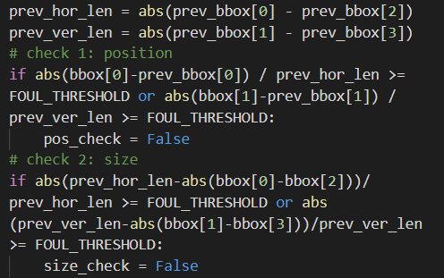

## Accuracy

The program successfully detects movements of both moving towards or away from the camera (change in bounding box size) and those moving around (changing in bounding box position). Both types of movements are tested in the person_test1 and people_test1_output videos.

# Red and Green Light Switching (Line 133-143)

## Methodology

### From green to red

mixer.music.get_busy() is to check whether the background music (i.e. the squid game music) is now playing. If not, the red_start_time is set to current time and music_on is set to False.

### From red to green

RED_LIGHT_LENGTH is a global variable indicating length of red light period in seconds. Due to the low fps, it is raised to 10 (and 15 when the rate is extremely low). Once again, please feel free to lower it if the fps is higher.

In each frame, the current time (time.time()) is compared with red_start_time to see if the number of seconds elapsed is larger than or equal to RED_LIGHT_LENGTH. If yes, the background music is played and music_on is set to True, all detection stops.

# Object Detection

## Methodology

Basically it is from the code given in object_tracker.py. Only modification made is setting allowed_classes to person only.

## Accuracy

In general, the normal model performs slightly better than the tiny model, but the difference is not big. The same frames from the source video are selected to compare their performance.

### Normal Model

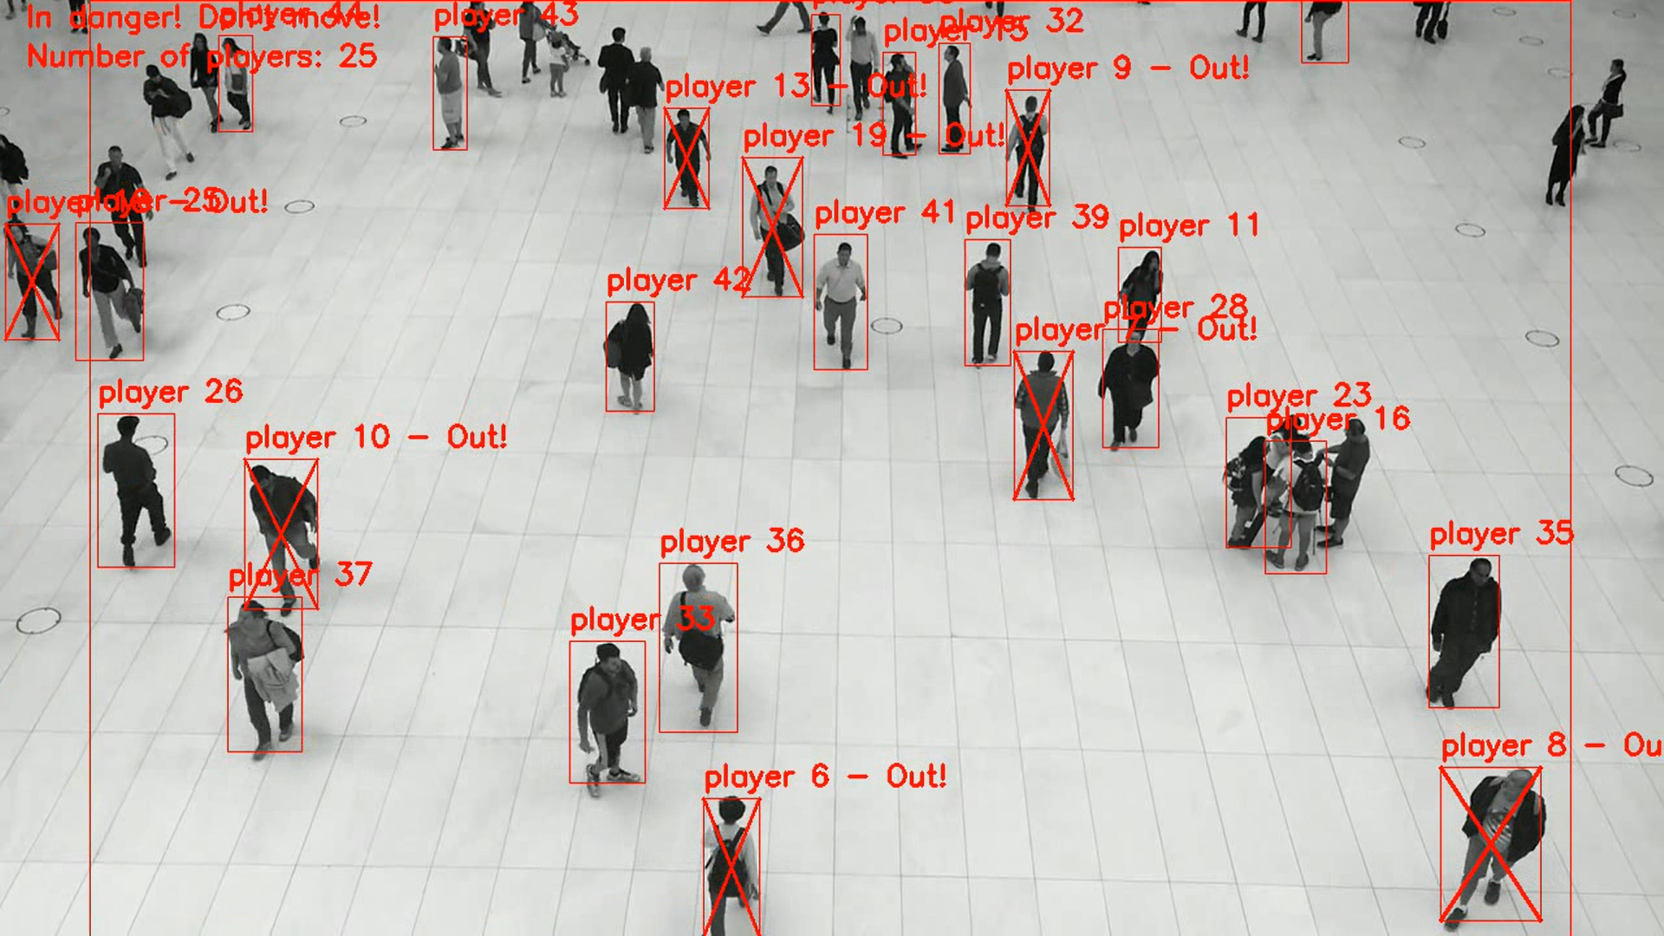 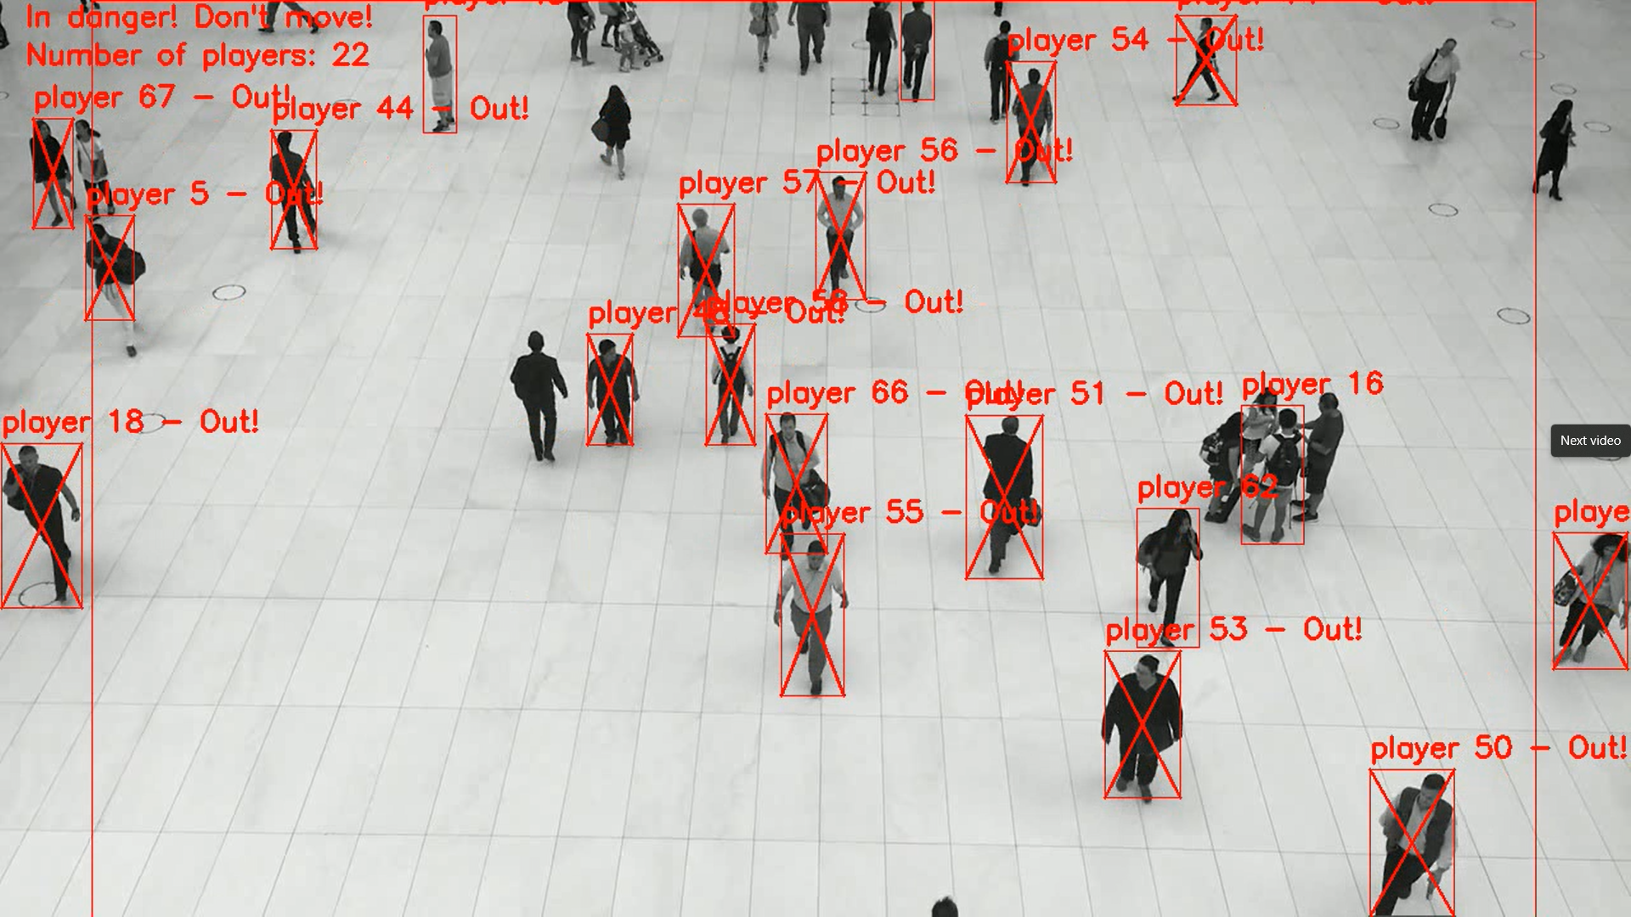

### Tiny Model

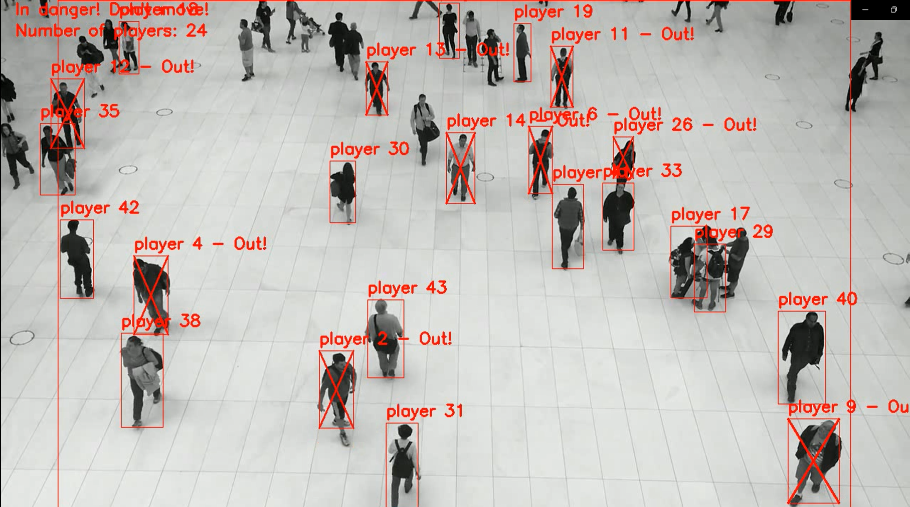 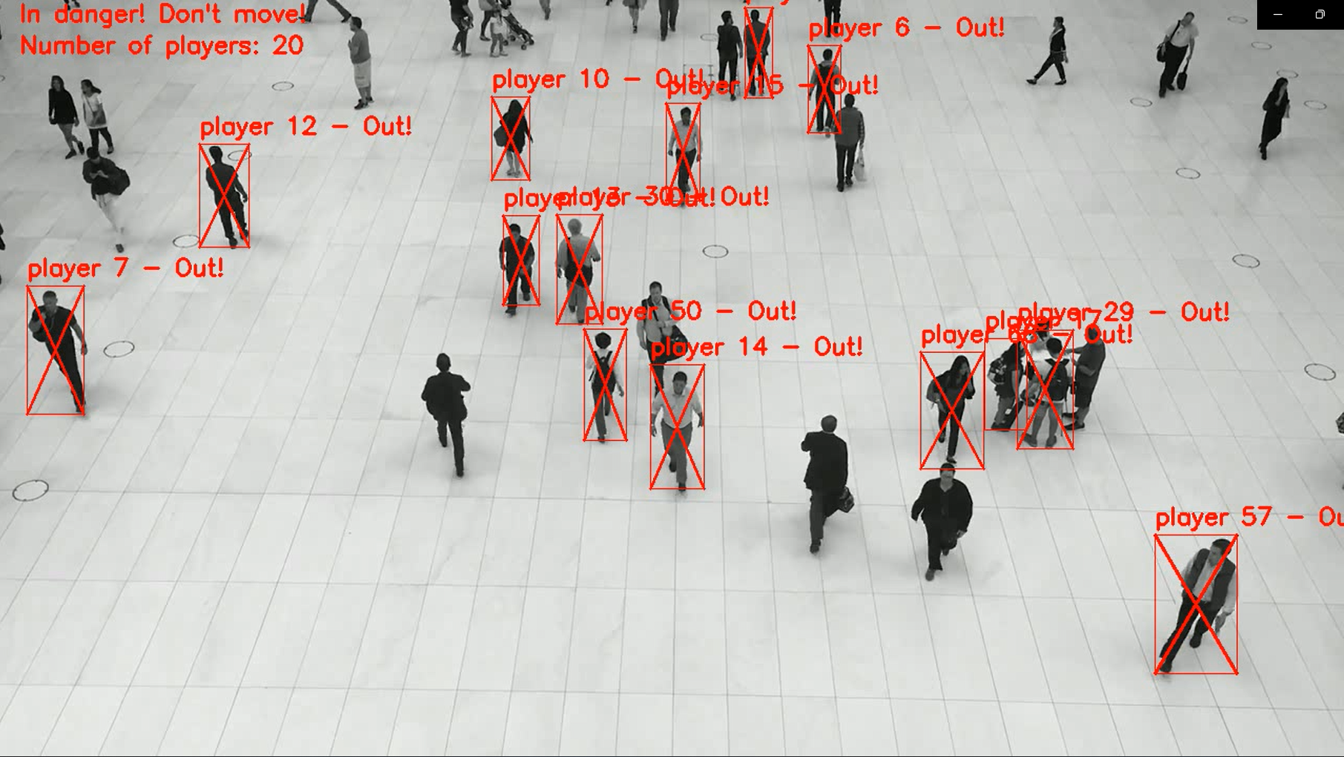

# Player Elimination

## Methodology

out_list is a list of all track_ids of eliminated players. It is added when a player in eliminated during sampling. If a player is eliminated, an “Out” is added to its text label and a cross is added to its bounding box also.

## Performance

The performance of the function is satisfactory as shown in testing.

# Minor touch-ups

Some minor adjustments were made to make the program works more like squid game.

## Gunshot

Using pygame sound object, a gunshot sound effect is played when a player is eliminated.

## Red Bounding Box

Compared to the original format *(left pic)*, I bounded all person object with red box and changed the text format to player (player number), so it looks more like squid game *(right pic)*.

